**Exercise 7: Implementing Constructor and Setter Injection**

**Scenario:**

**The library management application requires both constructor and setter injection for better control over bean initialization.**

**Steps: These are the Steps**

**1. Configure Constructor Injection:**

**o Here , we update applicationContext.xml to configure constructor injection for BookService.**

**Ans. Here is the applicationContext.xml**

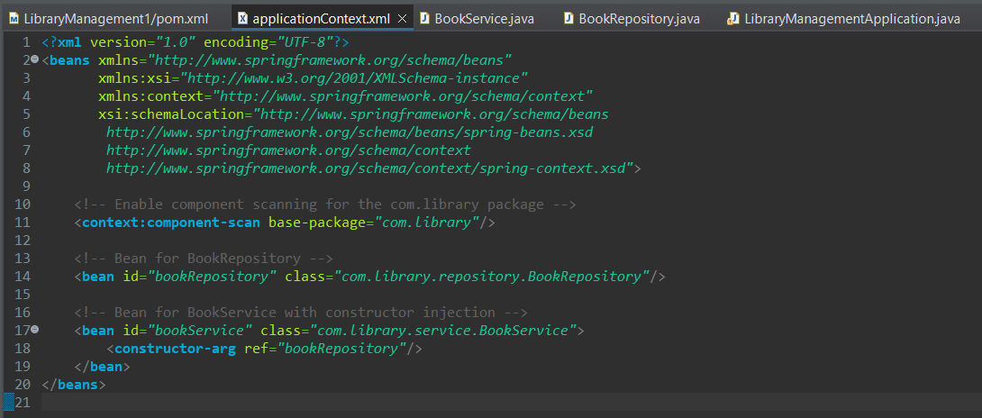

**2. Configure Setter Injection:**

**o Ensure that the BookService class has a setter method for BookRepository and configure it in applicationContext.xml.**

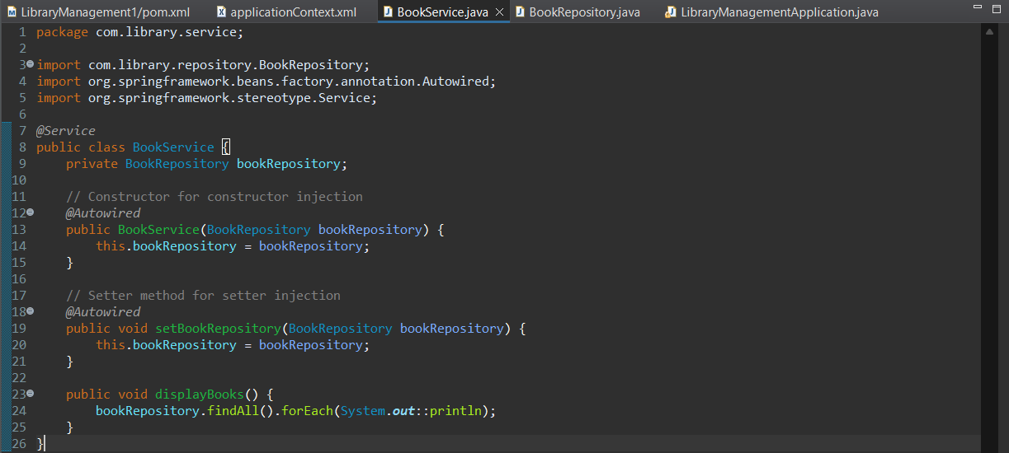**Ans.**

**3. Test the Injection:**

**o Run the LibraryManagementApplication main class to verify both constructor and setter injection.**

**Ans.**

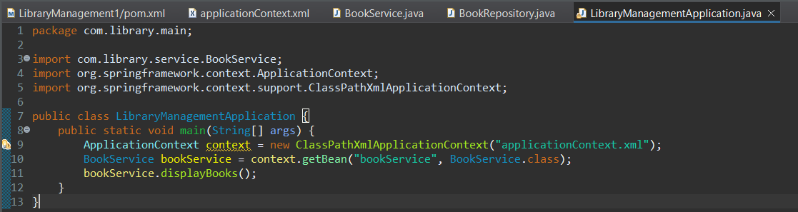

**Output: -**

